CREATE JAVA APPLICATION

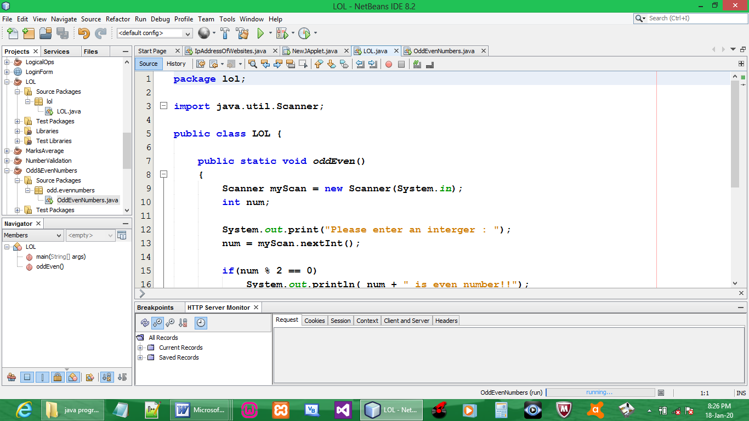

CODE:

package lol;

import java.util.Scanner;

public class LOL {

public static void oddEven()
{
Scanner myScan = new Scanner(System.in);
int num;

System.out.print("Please enter an interger : ");
num = myScan.nextInt();

if(num % 2 == 0)
System.out.println( num + " is even number!!");
else
System.out.println( num + " is odd number!!");
}
public static void main(String[] args) {
oddEven();
}
}

OUTPUT:

